Disclaimer:  
The program is not fully tested and there are chances that it might have wrong calculations and errors from time to time. In the last chapter of documentation, you can send me an email so I can remedy the situation. Fully test it first by giving it real data and checking if the results are accurate.

**USER’S**

**MANUAL**

*Stockbook: An Inventory and Transactions for Small and Medium Businesses*

August, 2017

**USER'S MANUAL**

**TABLE OF CONTENTS**

Table of Contents

1.0 GENERAL INFORMATION 5-1

1.1 System Overview 5-1

1.2 Project Files 5-1

1.3 Authorized Use Permission 5-1

2.0 Getting Started 5-1

2.1 Installing the Program using release files 5-1

2.2 Opening the program 5-1

2.3 Uninstalling the program 5-1

2.4 Database 5-1

2.5 Excel Format 5-2

2.6 Starting the program 5-2

2.7 Exit the Program 5-2

3.0 Products 5-1

3.1 Adding Products 5-1

3.2 Editing Product 5-2

3.3 Deleting Product 5-3

3.4 Export Product 5-3

3.5 Filter/View Product 5-5

4.0 Transaction 5-1

4.2 Add Purchased 5-3

4.3 Export Group Transactions 5-3

4.4 Filter / View Transaction 5-4

4.5 Details Transaction 5-5

4.6 Delete Transaction 5-5

4.7 Export Single Transaction (Invoice) 5-6

4.8 Configure the Settings 5-7

5.0 Error/Change Request 2

5.1 Inquiry Request 2

5.2 Change Request 2

5.3 Error Fix Request 2

**1.0 GENERAL INFORMATION**

1. **GENERAL INFORMATION**
   1. **1.1 System Overview**

General information of the program

1. Target Framework - .NET Framework 4.5.2
2. Target Operating System – Windows 7 and above
3. Project Build – Windows Presentation Form
4. Developer – Franz Justin Buenaventura
5. Included Libraries:
6. *Newtonsoft.Json:* For performing JSON Converts and file encryption and decryption
7. *MahApps.Metro:* For the Modern UI Theme
8. *EPPlus:* For Excel export and import
   1. **1.2 Project Files**

Open source: https://github.com/franzbuenaventura/Stockbook

* 1. **1.3 Authorized Use Permission**

The project is currently open source, that can be compiled and used by anyone as long as the owner is attributed if it’s commercially used.

**2.0 GETTING STARTED**

1. **Getting Started**
   1. **2.1 Installing the Program using release files**

To install the program, just open the latest release version and double click “setup.exe” as seen in the image below.

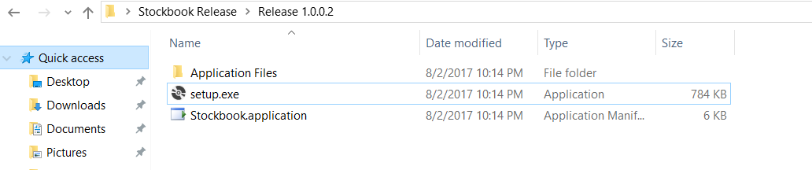

Click Install and it will install and open the program immediately.

* 1. **2.2 Opening the program**

The program can be easily open by clicking the “Stockbook.exe” with the image below.  
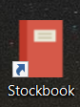

It can also be open by searching “Stockbook” in the start menu to see the shortcut

* 1. **2.3 Uninstalling the program**

You can easily uninstall the program by going to “Add or Remove program” and looking for the Stockbook program and press uninstall.

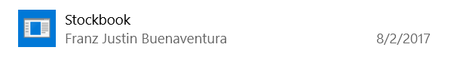

* 1. **2.4 Database**

The database of the program consists of 3 folders Settings, ProductsDb, and TransactionsDb. The contents of the two latter folders are json files specifying for each product and transaction. The settings folder contain the config file and the default auto backup folder.

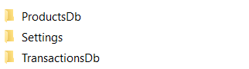

* 1. **2.5 Excel Format**

There are three xlsx files in the program, each consist of its own format and style. If you desire to change the format or add images or other concerns. Please do contact me via Email

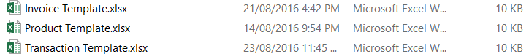

* 1. **2.6 Starting the program**

After opening the program, it will show a window like this

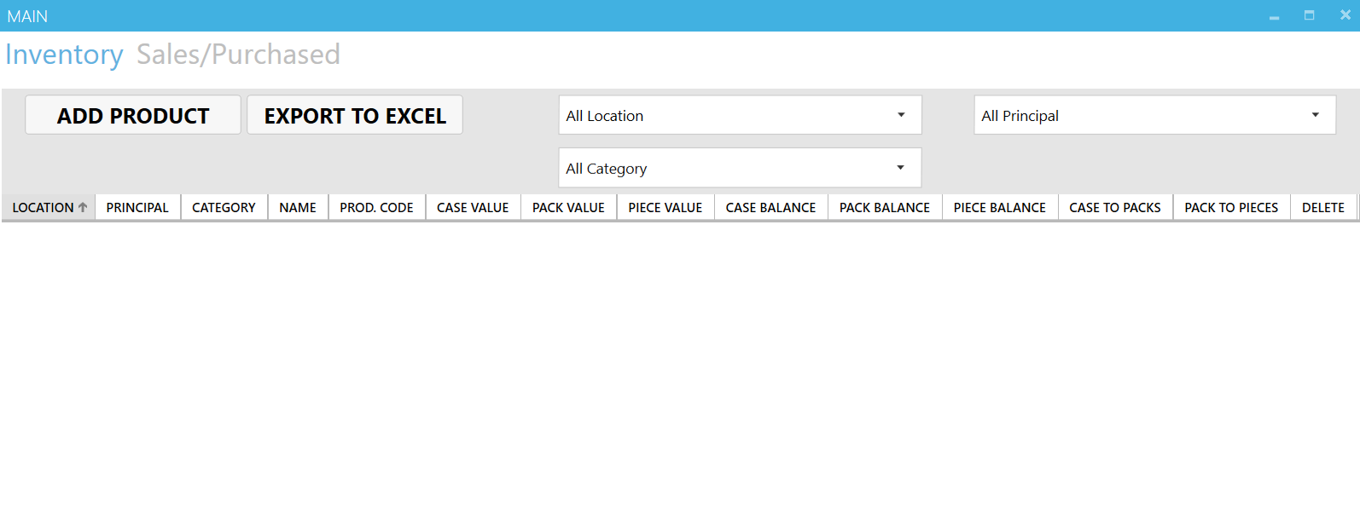

There are no products yet that is why the display is empty.

* 1. **2.7 Exit the Program**

To exit the program, you just need to closed all the Windows of the program by pressing this button



**3.0 Products**

1. **Products**

After starting the program, you should be in the Inventory page that can be seen in the top left corner of the program which looks like this:

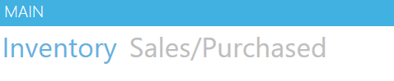

The blue highlighted word should be in the Inventory.

* 1. **3.1 Adding Products**

Click “Add Product” to start adding products

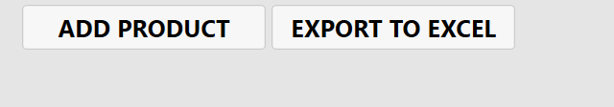

After clicking it, another window will pop up

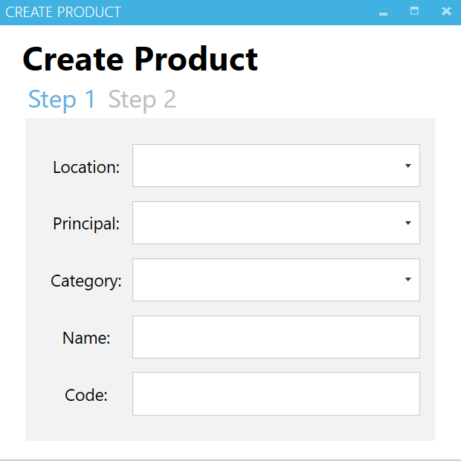

**5**

**4**

**1**

**2**

**3**

*1. Location – The location or storage of the product

*2. Principal – The company that owns the product or the supplier

*3. Category – The category of the product2  
*4. Name – The Name / Description of the product

*5. Code – The product code of the product

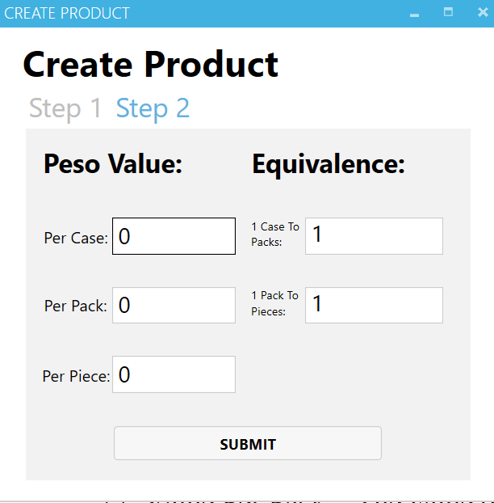  
*6. Value Per Case – The value of each case of the product

**9**

**10**

**8**

**7**

**6**

*7. Value Per Pack – The value of each pack of the product  
*8. Value Per Piece – The value of each piece of the product

*9. Case to Packs– The equivalence of a single case to packs  
*10. Pack to Pieces– The equivalence of a single packs to pieces

After clicking the “SUBMIT” button, the window will close and the Main Window will refresh its items.

*Note: You can put the Case to Packs and Pack to Pieces to 0, so it would not convert automatically.   
If product does not have any pieces only Cases and Packs, you can leave pack to piece to 1 and it will automatically convert all piece (if you input) to pack.   
  
Editing the Case to Pack and Pack to Pieces was disabled, it presents a lot of vulnerabilities for the continuity of the program. If a product has a different “Case to Pack” or “Pack to Piece”, it should be added as a different product

* 1. **3.2 Editing Product**

The editing for the products are simple, you just need to double click it like in excel



When you click it will look like this:



Then you can change the value, to avoid accidents another Window will popup

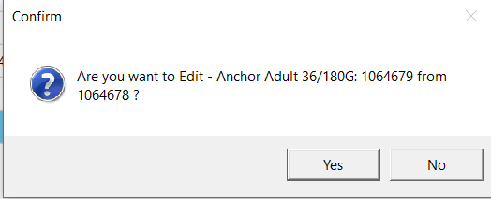

You just need to click the Yes to save changes, or press No if you want to cancel.

You can’t edit “Case to Packs” and “Packs to Pieces”, check the note in 3.1.

* 1. **3.3 Deleting Product**

To delete a product, you need to click Delete in the right most column of the row of the product.



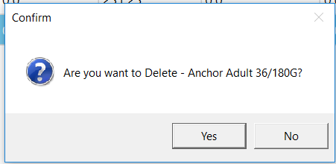

Just press Yes to delete the product, and No to cancel.

*Note: The product will be deleted but the product in Transaction (Sales/Purchased) will not be affected and will remain the same.

* 1. **3.4 Export Product**

To export a product, you just need to click the “Export to Excel button” which is located at the top left corner beside the add product. 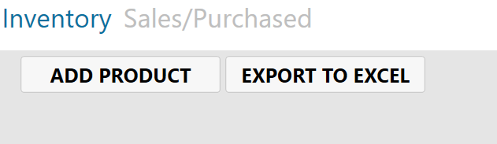

After clicking the button, it will open another window

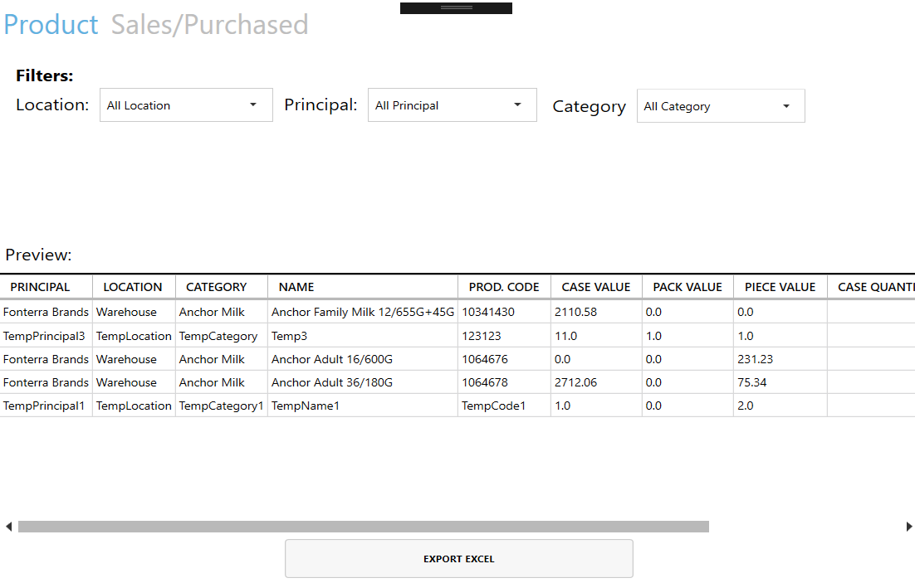

**6**

**5**

**4**

**3**

**2**

**1**

1. Product – You’re in product page and currently exporting Products data

2. Filter Location – Filter the products with the desired location

3. Filter Principal – Filter the products with the desired principal

4. Filter Category – Filter the products with the desired category

5. Preview – This will be the preview list of the products that will be exported

6. Export Excel – The export button after meeting the desired product list.

Click “EXPORT EXCEL” when you are ok with the preview then it will ask you where the downloaded file to be save and just click “Save” to export the data.

* 1. **3.5 Filter/View Product**

The same with export, you can also filter the products in the preview panel.   
By selecting the wanted parameters just by clicking the dropdown button.

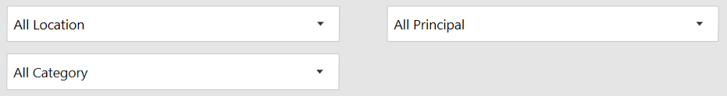

**2**

**1**

**3**

Initially all filters are selected as “All” that means it will show all the possible products for the filter.

All the details about the product will be listed and initially sorted by Location.   
You can click the header of a column to sort the list of products with the header in ascending order or click again for descending order.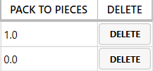

The columns represent the details of a single product, while each product have its own rows.

From left to right, the product details are:

* Location
* Principal
* Category
* Name
* Product Code
* Case Value
* Pack Value
* Piece Value
* Case Balance
* Pack Balance
* Piece Balance
* Case to Packs
* Pack to Pieces

Explanation on each individual detail can be seen in 3.1 Add Product.

**4.0 Transaction**

1. **Transaction**

After starting the program, you should be in the Inventory page that can be seen in the top left corner of the program which looks like this:

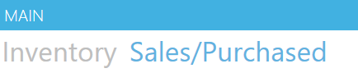

The blue highlighted word should be in the Sales/Purchased.

**4.1 Add Sales**

Click “Add Sales” to open the Sales Window

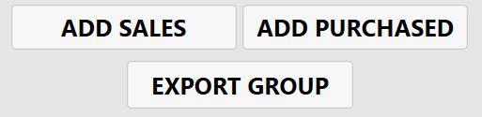

After clicking it, another window will pop up

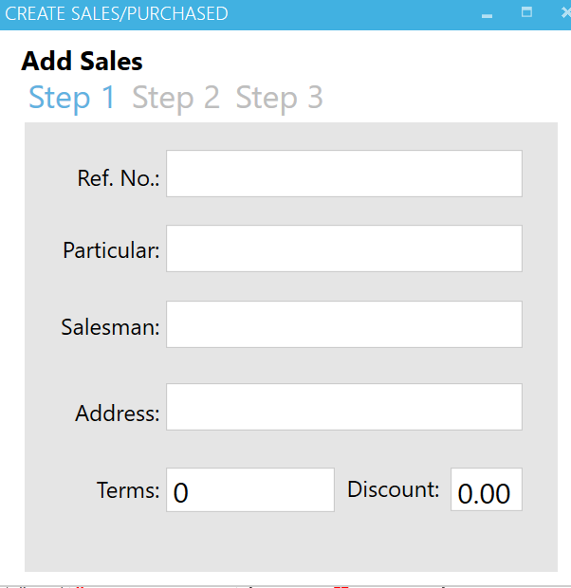

**6**

**5**

**4**

**3**

**2**

**1**

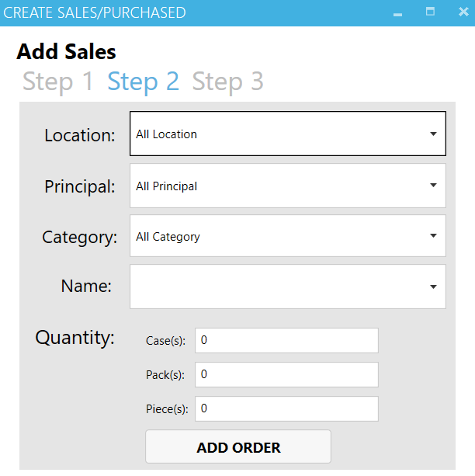

**11**

**9**

**10**

**7**

**8**

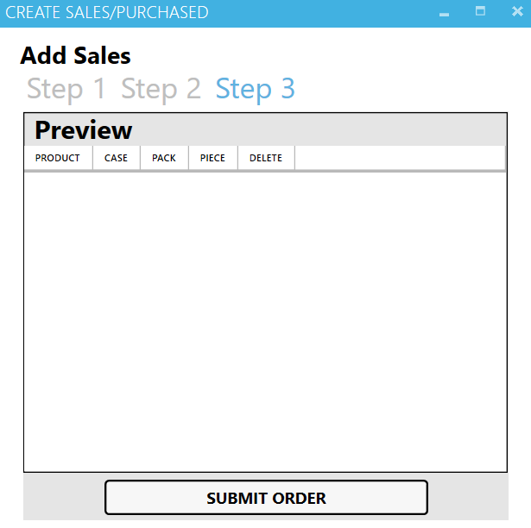

**12**

Make sure the top left corner of the window says “Add Sales”

|  |  |  |  |
| --- | --- | --- | --- |
| 1. Ref. No | Reference Number of Transaction | 7. Location | Location of the Products |
| 2. Particular | The particular or outlet of the Sales | 8. Principal | Principal of the Products |
| 3. Salesman | The agent who represents | 9. Category | Category of the Products |
| 4. Address | Address of the Particular | 10. Name | Name of the Products |
| 5. Terms | Terms (If none leave it to 0) | 11. Quantity | Quantity (Case/Pack/Piece) |
| 6. Discount | Discount in Percentage | 12. Preview | Added order of products in Sales |

The 1 – 6 input are the description of the transaction that will be made.   
The 7 – 11 input are for individual products that will be ordered.   
The 12 input will be the list of the ordered products.   
  
After inputting the 1-6 input, select the products that to be transact by inputting it in the 7 – 11 inputs. After that press the button “Add Order” at the bottom left of the window. It will erase 10 – 11 inputs and it will show that it is registered in 12 input which is Preview program. Repeat the process from 7 – 11 inputs until all products are inputted.

Press the Submit Order to finalize the order, this will close the window and will reflect the changes in Main Window.   
  
To check if its recorded, you should be able to see it in the Preview Panel in Sales/Purchased

* 1. **4.2 Add Purchased**

Click “Add Purchased” to open the Purchased Window



After clicking it, another window will pop up

Identical window with Add Sales in 4.1 except for the top right part which should say “Add Purchased”.

* 1. **4.3 Export Group Transactions**

Click “Export Group” to open the Export Window for Transactions

After click it, another window will pop up  
  
Identical with 3.4 Export Product but “Sales/Purchased” are highlighted:   


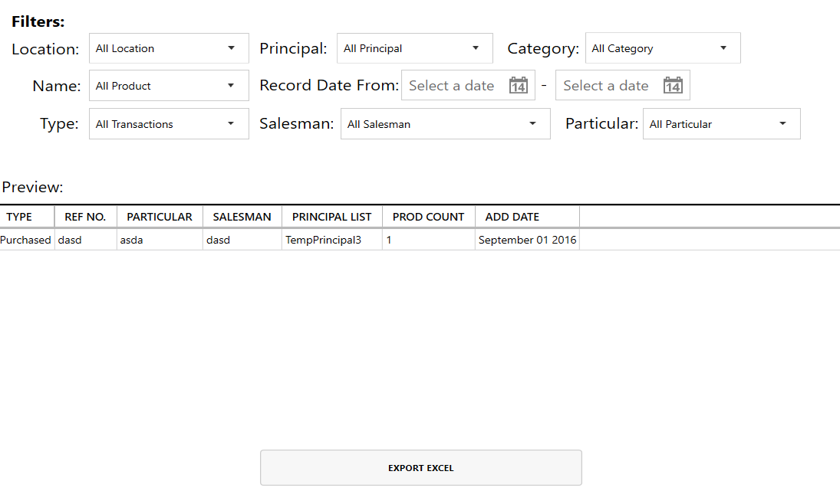

**10**

**9**

**8**

**6**

**7**

**5**

**4**

**3**

**2**

**1**

|  |  |  |  |
| --- | --- | --- | --- |
| 1. Location | Filter Location of Product | 6. Record Date | Filter by Date (From – To) |
| 2. Name | Filter Name of Product | 7. Salesman | Filter by Salesman |
| 3. Type | Type of Transaction | 8. Particular | Filter by Particular/Outlet |
| 4. Principal | Filter Principal of Product | 9. Preview | Preview of transactions to be exported |
| 5. Category | Category of Transaction | 10. Export | Export to Excel |

The exported excel will contain the summary of Transactions, if more than one Product chosen.   
It will be exported into new sheet in Excel.

* 1. **4.4 Filter / View Transaction**

Like the Filter/View Product in 3.5, the Transaction page has its own filter system for the preview

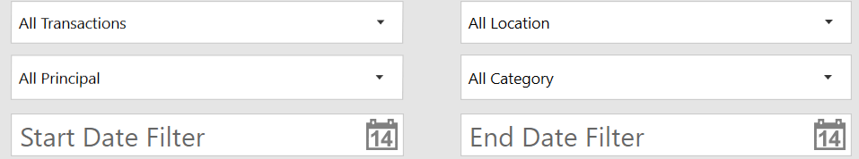

**5**

**6**

**4**

**3**

**1**

**2**

Initially all filters are selected as “All” that means it will show all the possible products for the filter.

All the details about the product will be listed and initially sorted by Type.

You can click the header of a column to sort the list of products with the header in ascending order or click again for descending order.



The columns represent the details of a single product, while each product have its own rows.

From left to right, the product details are:

* Type – Type of transaction (Sales or Purchased)
* Ref No. – Reference Number of given Transaction
* Particular – Particular or Outlet for the Transaction
* Salesman – Salesman that accepted the Transaction
* Principal List – List of Principal on the Transaction
* Product Count – Product count of a Transaction
* Add Date – The Date when the Transaction was created
* Details – Full details of Transaction
* Delete – Delete button for Transaction
* Export To Excel – Export the Invoice of Transaction
  1. **4.5 Details Transaction**

Click the Details button on the same row of the desired transaction

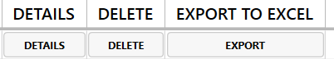

A new window will appear; all the details of the transaction will be present.  
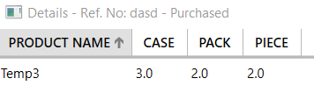  
The Title of the window will contain the Ref. No and Type of transaction.   
then a table of Products with its Case, Pack and Piece value in Transaction.

* 1. **4.6 Delete Transaction**

Deleting a transaction will reverse its reflected balance.   
So if you delete a Purchased Transaction, it will deduct it from the main balance that can be check in Products window.



After pressing delete, there will be a confirmation window that will ask if it confirms the deletion of that transaction.

* 1. **4.7 Export Single Transaction (Invoice)**

After pressing Export to Excel



It will then ask you where to save the file, you can change the name of the file to desired name.

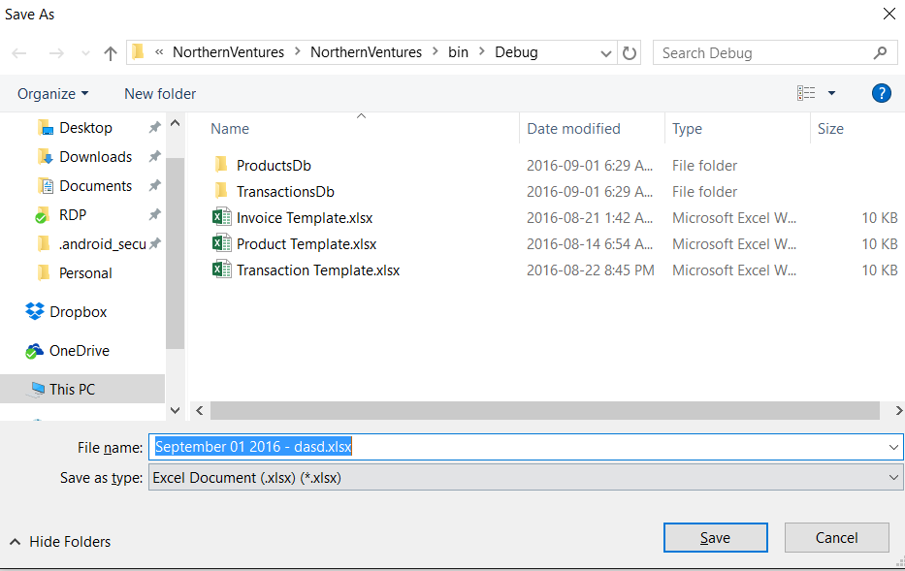  
  
You can browse to your desired target folder and click save.

* 1. **4.8 Configure the Settings**

To enter the settings of Stockbook, just click the top right button “SETTINGS”

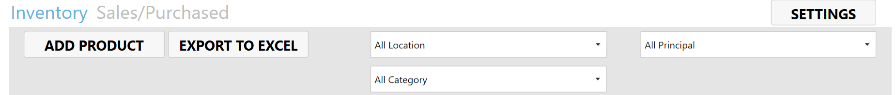

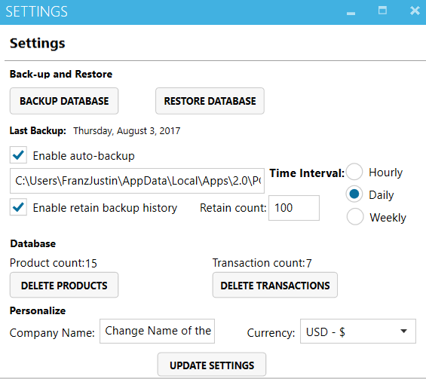

**15**

**13**

**14**

**12**

**11**

**5**

**10**

**9**

**8**

**7**

**6**

**4**

**3**

**2**

**1**

|  |  |  |  |
| --- | --- | --- | --- |
| 1. Backup Database | Backup the database including products and transactions | 1. Restore Database | Restore the database with the extension “.stockbook” both  products and transaction |
| 1. Last Backup | An indicator when was the last backup occurred in the system | 1. Enable   Auto-Backup | A check box for enabling auto-backup |
| 1. Location Database | The location where the database of the system will be stored, default is installation folder | 1. Time Interval | The time interval for backup frequency |
| 1. Enable Backup History | A check box for enabling to specify the number of backups count, disable means it will not delete anything | 1. Retain Count | The number of how many backups retains that is stored in the system |
| 1. Product Count | The count of all the products in the system | 1. Transaction Count | The count of all the transactions in the system |
| 1. Delete Products | Delete all the products in the system | 1. Delete Transactions | Delete all the transaction in the system |
| 1. Company Name | The name of the company that will use the system | 1. Currency | The currency that will be used for the system |
| 1. Update Settings | To finalize all the changes in the settings |  |  |

**5.0 Error/Change Request**

# Error/Change Request

All request shall be in Email, will be sent in [franz_buenaventura@outlook.com](mailto:franz_buenaventura@outlook.com) or post an issue in GitHub and will work with it: <https://github.com/franzbuenaventura/Stockbook/issues>. I will try my best to respond to your Request as soon as possible.

* 1. **5.1 Inquiry Request**

If you have any questions about the usage of program or clarifications on the instruction.   
Send me an Email with this format.  
  
Subject: [Inquiry][Northern Ventures] ‘Title’ (Put a 3 - 5 words Title)  
Body:

Inquiry: ‘What you want to ask or how to’  
Details: ‘What you need to see or expect to see’  
Pictures: ‘Attached Pictures if necessary for explanation’

* 1. **5.2 Change Request**

If you have any change request for program.   
Send me an Email with this format.  
  
Subject: [Change Request][Northern Ventures] ‘Title’ (Put a 3 - 5 words Title)  
Body:

Request: ‘What you want for the program to have and what will be its result’  
Details: ‘What are the details of your request, how should I make it’  
Pictures: ‘Attached Pictures if necessary for explanation’

* 1. **5.3 Error Fix Request**

If you have any error encountered in the program   
(Sudden Not Responding, Corrupt Data, Mismatch Information).   
Send me an Email with this format.  
  
Subject: [Error Fix Request][Northern Ventures] ‘Title’ (Put a 3 - 5 words Title)  
Body:

Error: ‘What is the error of the program, where in the program you receive it’  
Details: ‘What are the details of error, when did it happen and what are you doing when it happend’  
Pictures: ‘Attached Pictures if necessary for explanation’